Newsletter for Employees/Clients

Dear ______________,

Over the last two years, Birkman has been working on powerful changes to their reports that I am excited to share with you. My goal for this letter is to inform you of some of these changes and explain the some of the reasoning behind them.

Here is a list of what you may wish to know:

- New Component Names
The current Component names are all based on the concept of Needs. For example, your Need for Acceptance, your Need for Structure, etc. Although these names have served their purpose in the past, Birkman has found that individuals understand the concepts better when the name of the Component is more descriptive of what is truly being measured. To that end, they have renamed most of the Components to be more intuitive for you.

Esteem Self-Consciousness
Acceptance Social Energy
Structure Insistence
Authority Assertiveness
Advantage Incentives
Activity Physical Energy
Empathy Emotional Energy
Change Restlessness

Thought will continue to be called Thought.
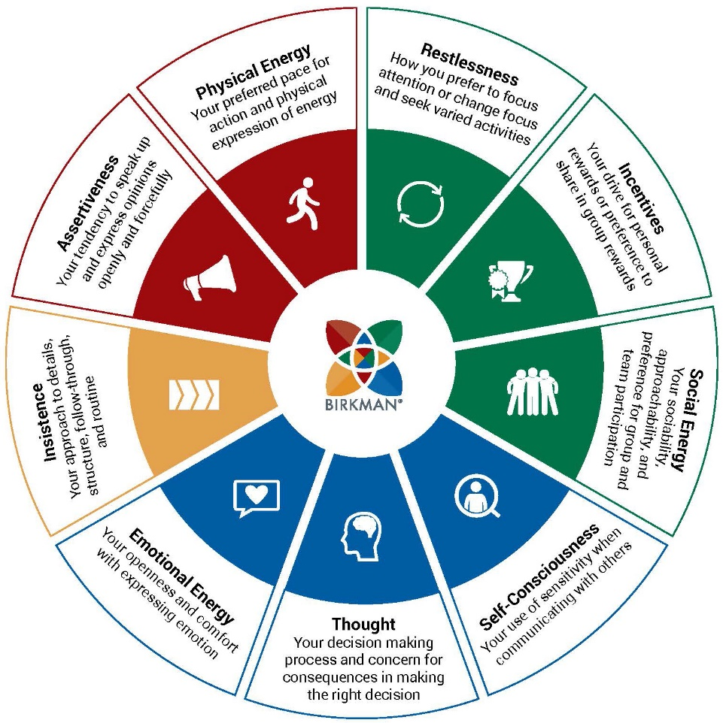

Keep in mind, Birkman has not changed what or how we measure each Component, only the names. Your scores and the descriptions will stay the same.

- Where are Challenge and Freedom?
You may have noticed Challenge and Freedom are missing from the list above. This is because Challenge and Freedom are attitude-based rather than behavior-based like the other nine Components. Challenge and Freedom will still be available to you, but will reside in their own special report called The Challenge and Freedom Report.

- New Component Order and Icons
In addition to changing the names of the Components, they also reordered the Components in a more logical manner and created icons to accompany each one.

- Social Energy
- Physical Energy
- Emotional Energy
- Self-Consciousness
- Assertiveness
- Insistence
- Incentives
- Restlessness
- Thought

- Birkman Interests
There are two important updates to the Birkman Interests.

- Clerical is now Administrative
- Mechanical is now Technical

- The Birkman Map - You are here!
The four-quadrant grid, formerly called the ‘Life Style Grid,’ will now be called the ‘Birkman Map.’ This change reflects the idea that it is a charting of your Birkman data and the coordinates of your personality. The Birkman Map is gradated and captures the multi-dimensional nature of the Birkman information.
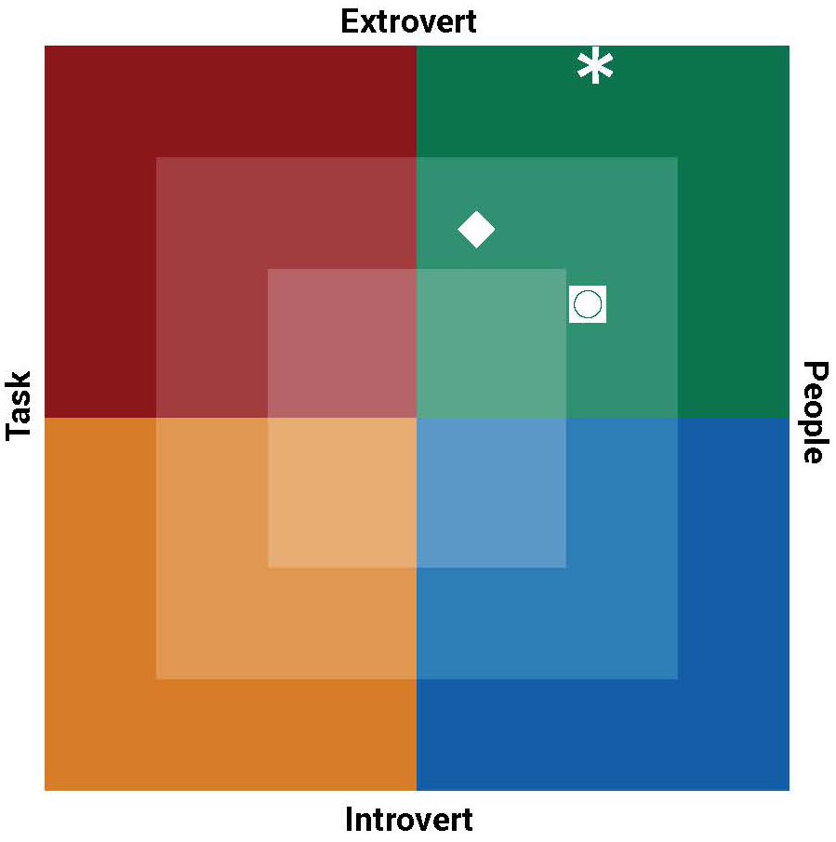

The other notable change on the Birkman Map is the shift from Direct/Indirect on the vertical axis to Extrovert/Introvert. This change highlights one of the key differentiators of the Birkman. As acclaimed psychology Carl Jung noted, “There is no such thing as a pure introvert or extrovert.” Most people are a blend of both. This concept is perfectly captured by the Birkman Map, where we can identify the combination of the two that make each person unique.

- New Visuals
The other notable change is an update to the look and feel of all the reports. Again, the content is the same but with redesigned reports including the latest in graphic and data visualization.

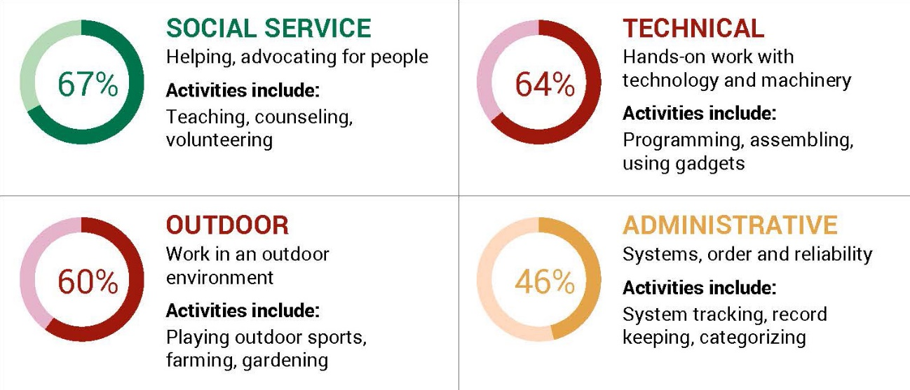

I am thrilled with the new look of Birkman, and hope you will be too!

(Insert customized paragraph about meeting with them to review their new Signature Report or their other business needs.)

Regards,
Your Name
Your Business

