[Insert welcome email from the organization or Organization Leader/Sponsor of Birkman Enterprise. See example below]

Welcome to Birkman! Our vision is to unlock individual and team potential through equitable, human-centered experiences for all. To accomplish this, we are excited to introduce Birkman, a benefit, tool and investment in your professional development. Birkman provides you with reliable, data-driven insights to improve communication, propel collaboration and drive your teams forward.

What is Birkman?

Every individual has a unique, complex personality. By understanding how personality impacts team chemistry, colleagues and leaders can transform teamwork into teams that work. Backed by over 70 years of research and trusted by more than 10,000 organizations worldwide, Birkman helps organizations create a connected culture that drives team momentum. [Check out this video](https://vimeo.com/441371478) to learn more about Birkman. Some benefits of using Birkman include:

* **Communicate effectively** by understanding preferred communication styles, opening the door to constructive dialogue and collaboration.
* **Understand your team** and leader’s motivations, expectations, and stressors to form stronger relationships.
* **Engage in healthy conflict** and problem solving more effectively by appreciating and leveragingdifferences.
* **Collaborate more intentionally** by creating a shared purpose, ensuring clarity throughout the team, and fostering a culture of psychological safety.

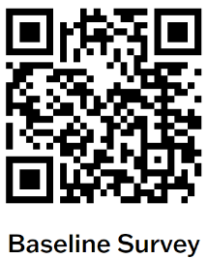Get Started: [CUSTOMIZE THESE STEPS FOR YOUR ORGANIZATION]

1. Take the **Baseline Survey** using the QR code (~1 minute)
2. Open the email from [birkmanquestionnaire@birkman.com](mailto:birkmanquestionnaire@birkman.com).
3. Click the link to complete **The Birkman Method Questionnaire** (~30 minutes).
4. To gain access to **MyBirkman**, open the email from [support@birkman.com](mailto:support@birkman.com).

**Note:** Your organization will assign you a MyBirkman account (this may take a few days).

1. Click the link to [mybirkman.com](mailto:mybirkman.com), enter your email and create a unique password for MyBirkman.

**Note:** If you didn't receive the email, visit [mybirkman.com](mailto:mybirkman.com) and click "forgot password" to reset it.

1. Explore MyBirkman and gain access to your Birkman data, your colleagues' data (Connections) and resources to deepen your connections (Action).
2. Complete this 2-minute pulse survey before the workshop: <https://www.surveymonkey.com/r/7TRZKSC>

Attend <Insert Name of Workshop>:

**When:** <Date and Time>

**Where:** <Location or link to register>

MyBirkman.com

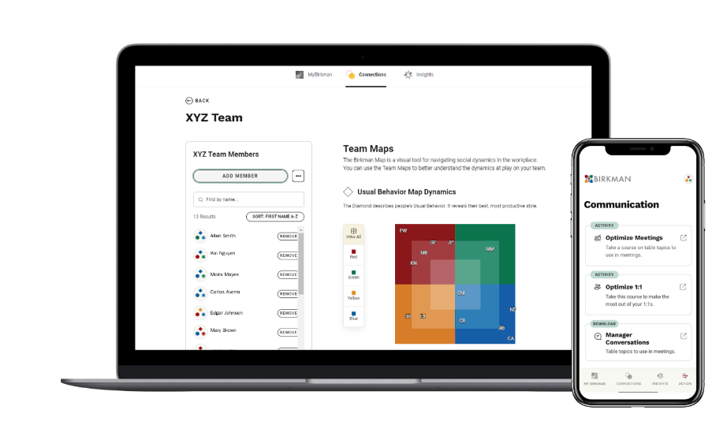After completing the Birkman questionnaire, your MyBirkman experience will bepersonalized to you.

* ***Daily Insights*** are customized to help you reflect on your strengths, needs, and stressors, especially as it relates to others. Check this daily to build your self-awareness.
* ***Your Birkman Map*** is a visual tool that shows your Usual Behaviors (strengths), Needs (expectations) and Interests (motivations) and how they compare to others.
* ***Connections*** help you reallyget to know your colleagues and improve your ability to work together. Search by name and create *Favorites* and *Teams* visible only to you.
* ***Action*** contains activities and resources to help you use Birkman as a tool to build better work habits, stronger communication and relationships, and ultimately, be the best version of you.

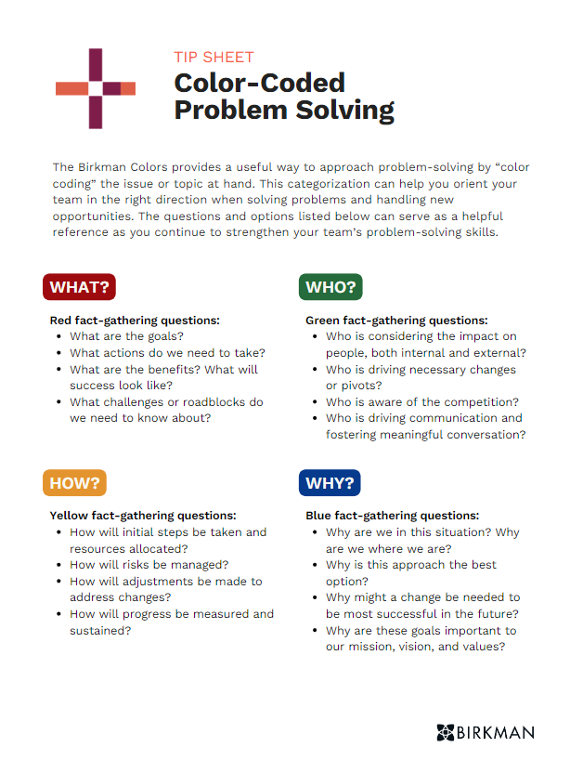MyBirkman.com Activities

MyBirkman empowers you to improve your relationships, self-awareness, and productivity. Visit the ***Action* page** for activities to use in the flow of work. Here are some examples of ways you can get started:

1. **SuperQ Scores** reflect how similar or different you and a colleague see the world.
   * Go to *Connections* and find a colleague by name.
   * Click *Compare* to see how different you are and review your *Shared Interests* and *Your Needs & Their Needs*.
   * Meet with the colleague and explore this together!
2. ***Let’s Talk Birkman*** questions help you build deeper and stronger relationships in the workplace.
   * Go to *Action* and click *Get Started*.
   * Take 5 minutes at the beginning of a meeting or conversation to invest in your colleagues on a deeper level!
3. ***Color-Coded Problem Solving***Tip Sheet offers insightful prompts to strengthen your team’s approach to complex issues.
   * Go to *Action*, scroll to *The Birkman Method Resources.*
   * Download any of the resources to help you with your personal development, lead others and work in teams.