# The SuperQ

The SuperQ is a high-level score available on the MyBirkman platform. Overall, the SuperQ measures how differently two people see the world. The goal of the SuperQ is to spark curiosity, which leads to conversation and, ultimately, deeper connection. A SuperQ score can be derived for each person an individual is connected to within the MyBirkman platform.

# What does the SuperQ score mean?

The SuperQ is like a 100,000-foot comparison between two people. Its scores can range from 1 to 99%, with 1 being the low end of the scale and 99 being the high end.

* Lower Scores of 1 to 39%: These two people make sense of the world similarly.
* Higher Scores of 61 to 99% - These two people see the world differently regarding their motivations, expectations, and/or how they approach situations.
* Scores ranging from 40 to 60 can be considered moderate, just like all Birkman scales.

# How is the SuperQ scored?

The SuperQ is scored by examining how two people answered questions in all three sections of the Birkman Questionnaire and then determining how similar or different their answering patterns were to each other. The SuperQ score reflects the percentage of people in the workplace who are more or less different from the two people being compared.

A SuperQ of 70% looks like this:

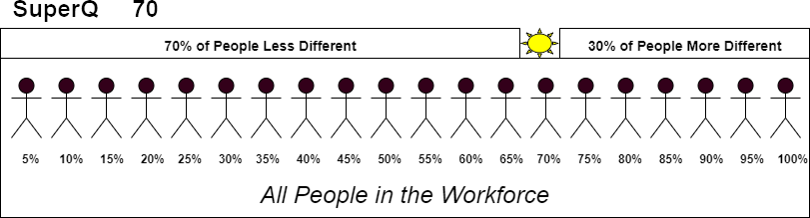

A SuperQ of 30% looks like this:

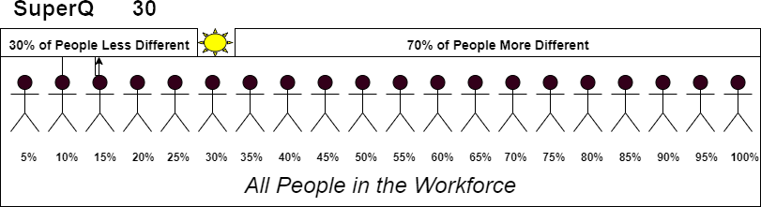

# FAQ’s

* Can I access the SuperQ in Birkman Direct?

The SuperQ score is only found in the MyBirkman Platform.

* What is the difference between the SuperQ and other Birkman scales?

Where most Birkman scales are designed to deeply explore a certain aspect of someone’s personality, the SuperQ is designed to spark conversation between two people and use the score as a jumping-off point into other Birkman data.

* Where does the name SuperQ come from?

Birkman's questionnaire is nicknamed the “Q,” the word “super” makes the scale sound playful and fun.

* Are any scores better than others?

No, like all Birkman scales, every SuperQ score will face strengths and potential challenges to the relationship.

* What is the SuperQ designed for?

The Super Q is designed to spark conversation based on how similar or different two people are from each other.

* How can I have the same Birkman Map colors but different SuperQ scores with two people?

The SuperQ score is based on how you and someone else answered the entire questionnaire. Each dimension of The Birkman Map has multiple questions specifically from a section of the questionnaire tied to each dimension. To get a similar score for each dimension, you

answered a certain number of questions in a certain way to get the same score. Your SuperQ can be different because you may have endorsed the same number of questions on a scale

to get equal scores, yet the questions you endorsed differed from those the other person endorsed, causing your SuperQ to be higher. For example, if a scale comprises 10 questions from a section of the questionnaire, you need to endorse 6 questions in a certain way to get a certain score. One person may endorse questions 2,4,6,8,9,10, and the other may

endorse 1,2,3,5,7,9 in that direction. They would get the same score on The Birkman Map, but their SuperQ would be high because they answered questions overall differently.